**RSA Cryptography**  
Invented by Rivest, Shamin and Adelman  
  
Its a public key cryptography, based on numbers.  
In this a message is represented by a number or a series of numbers. To get from a message to a number, we can take the string and compute the ASCII code of that character, which can be formed as a number   
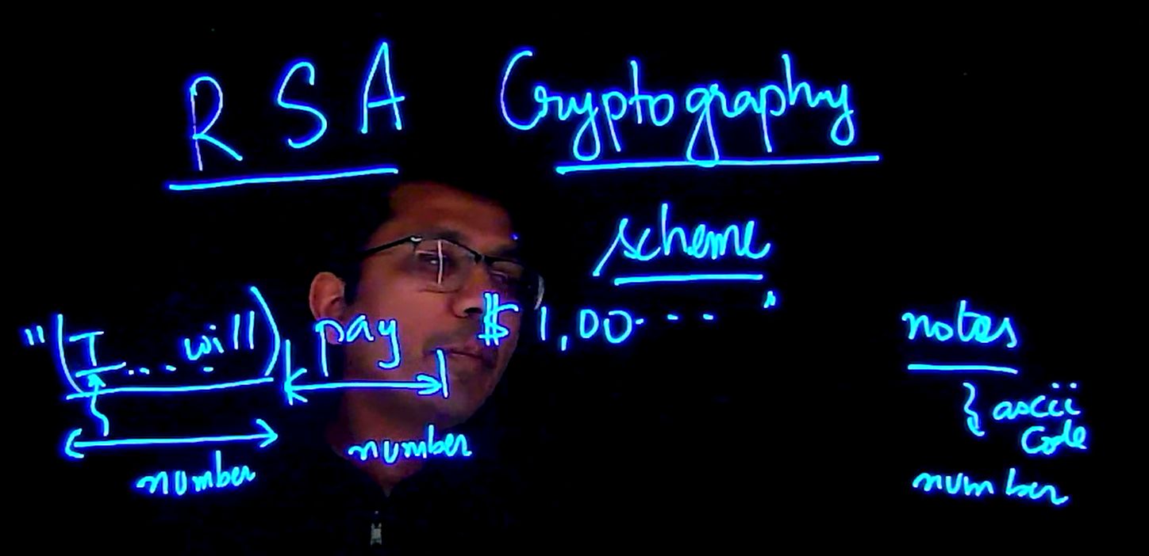  
  
The first Goal:  
How to take a message and write as a number   
  
To do that we compute the number n which the product of two large numbers  
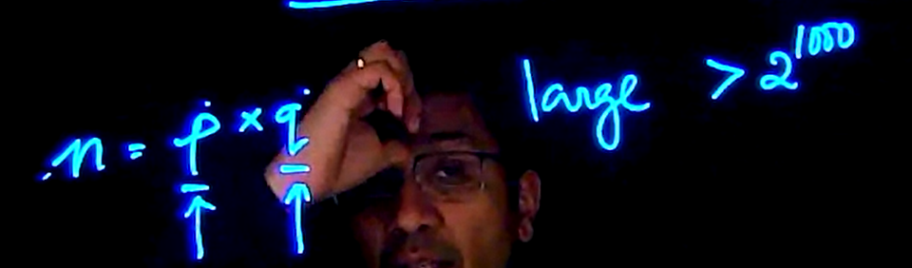

P =17  
q =19  
n = 17*19  
n = 323

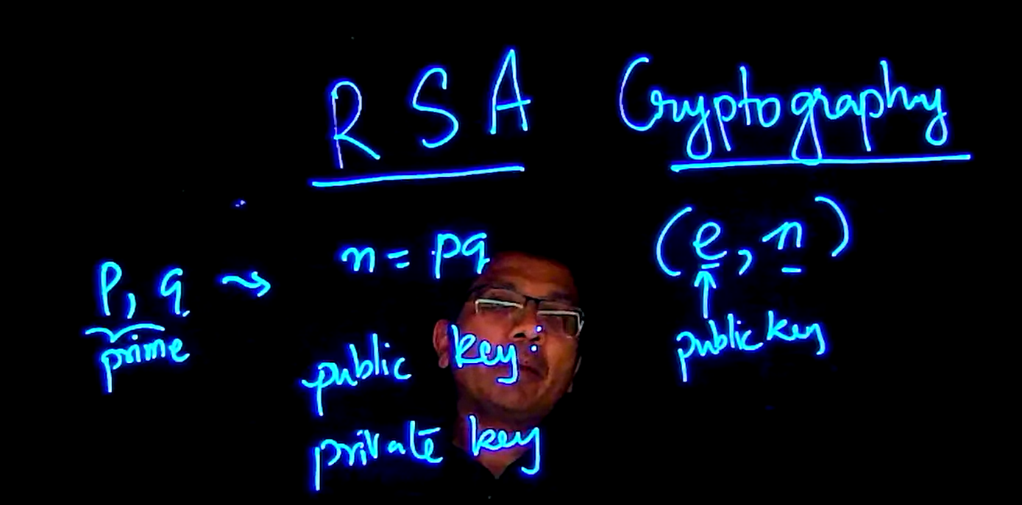

Two numbers are relative prime when GCD (m,n) = 1 (Which means, no common factors other than 1)

How how does RSA does the encryption:  
It calculates the M to the power mod n which is equal to the encrypted message, below shown  
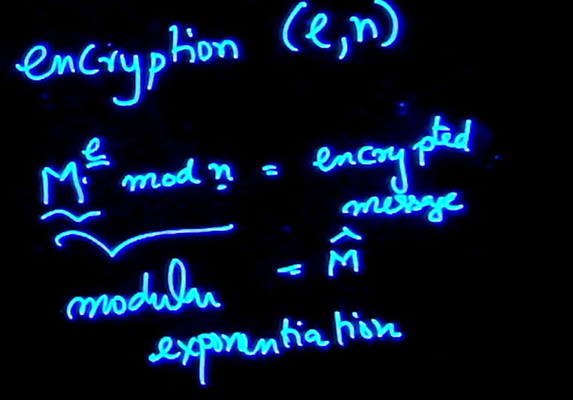   
  
Example  
n = 55, e = 4  
  
M = 11  
11^4 mod 55 = (121 mod 55)^2 = 11  
This example is with respect to small numbers, but with big numbers, things are different.  
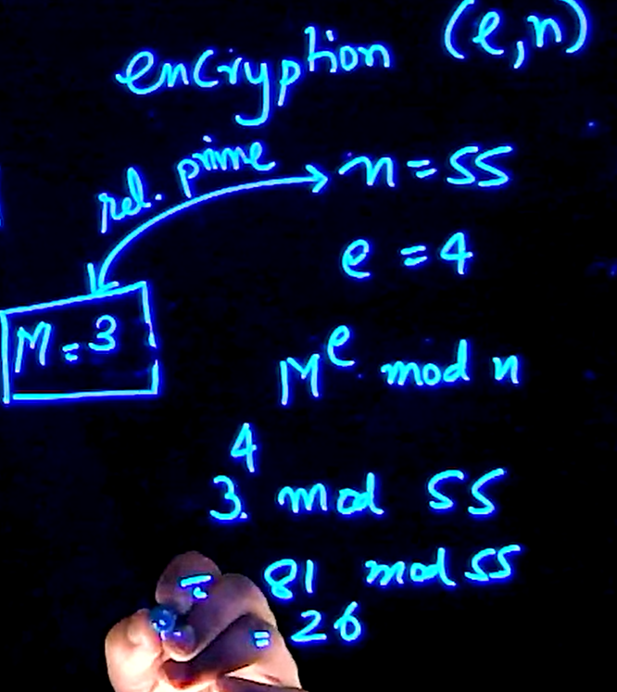  
This was for the public key now we need the private key   
  
But first here some more notes for public keys   
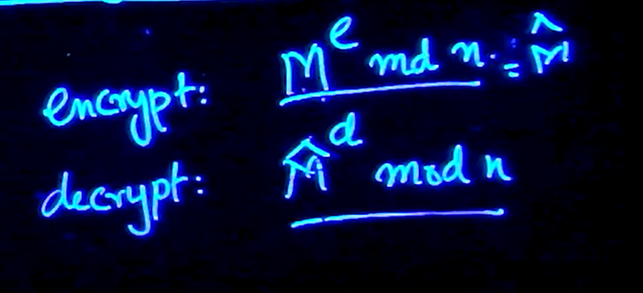

The flow is like this   
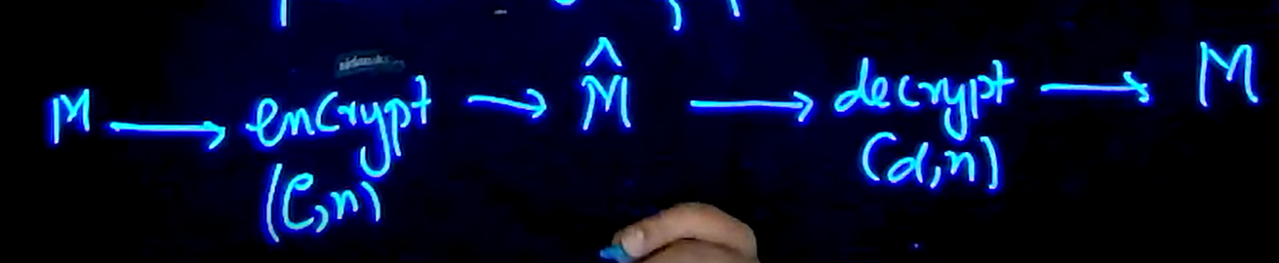

We use the Euler Totient Theorem to do the following steps, to find the relative prime numbers with respect to n  
  
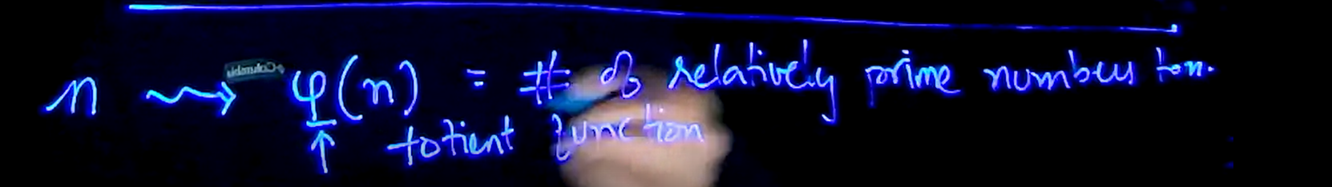

55 has a relative prime number which are 40, relative prime means, when GCD (m,n) = 1 (Which means, no common factors other than 1)  
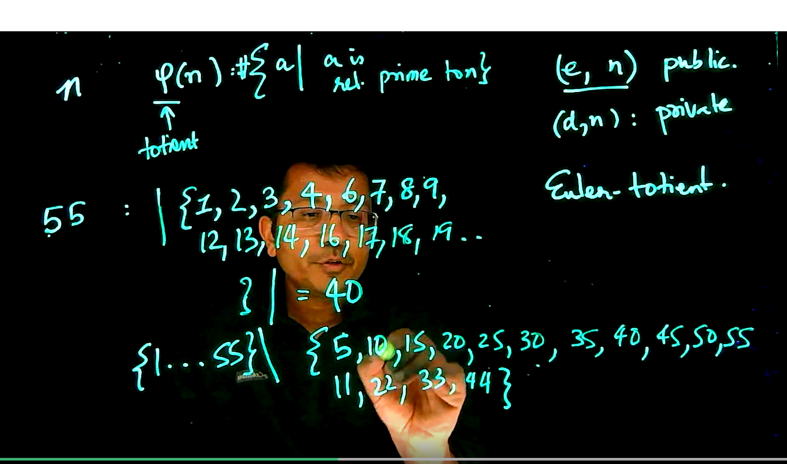

So the totient of a number is the count of the number of numbers that is relatively prime, which is indicated below.   
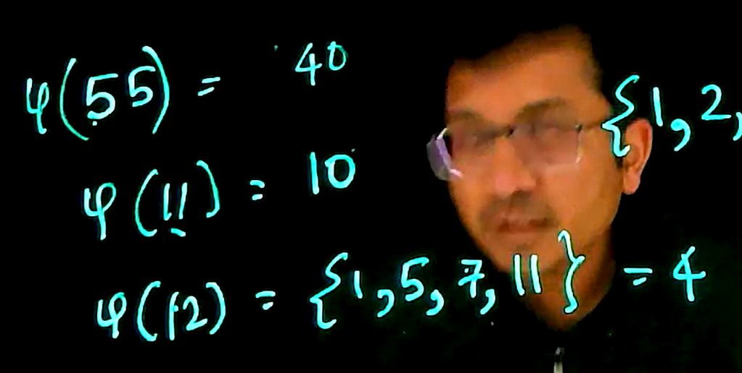

Example to find the totient of a function:  
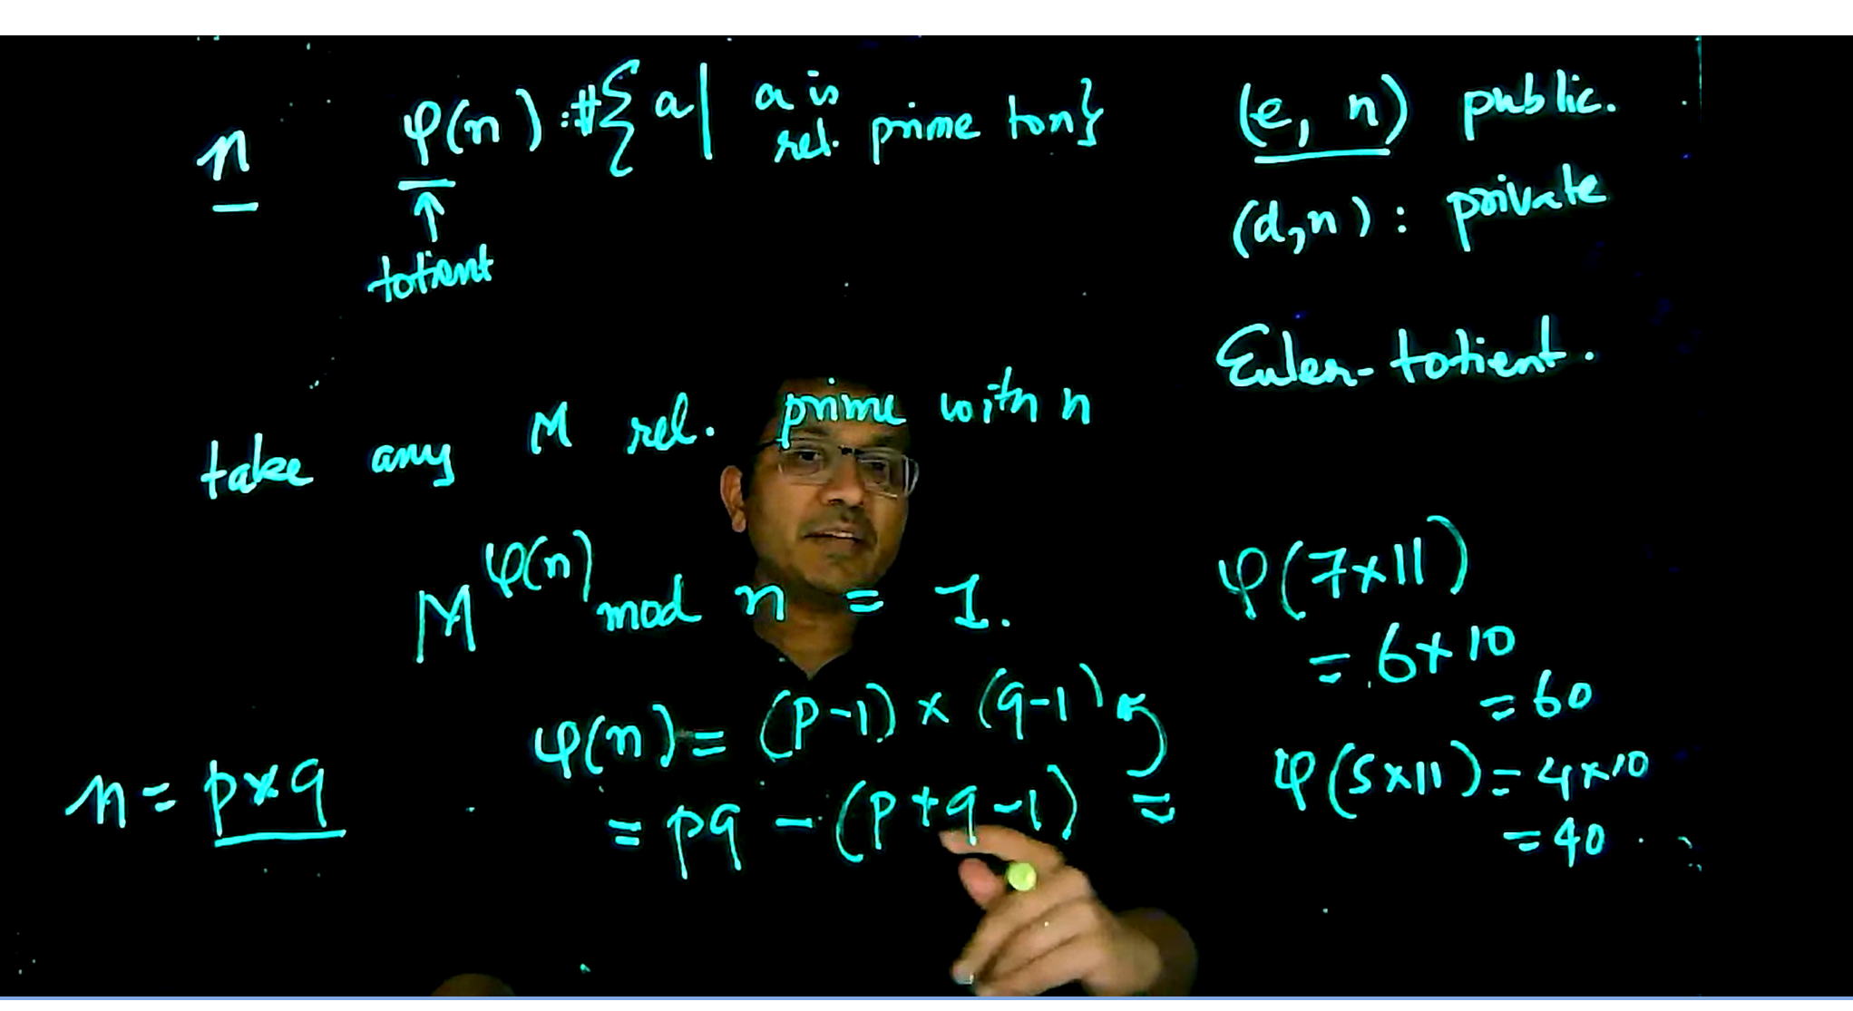  
  
How to find a totient of a functions:  
Steps:

This is how blew, we can find the original message by using the formula stated below   
M raise to power (product of encryption and decryption number ) with mod of n

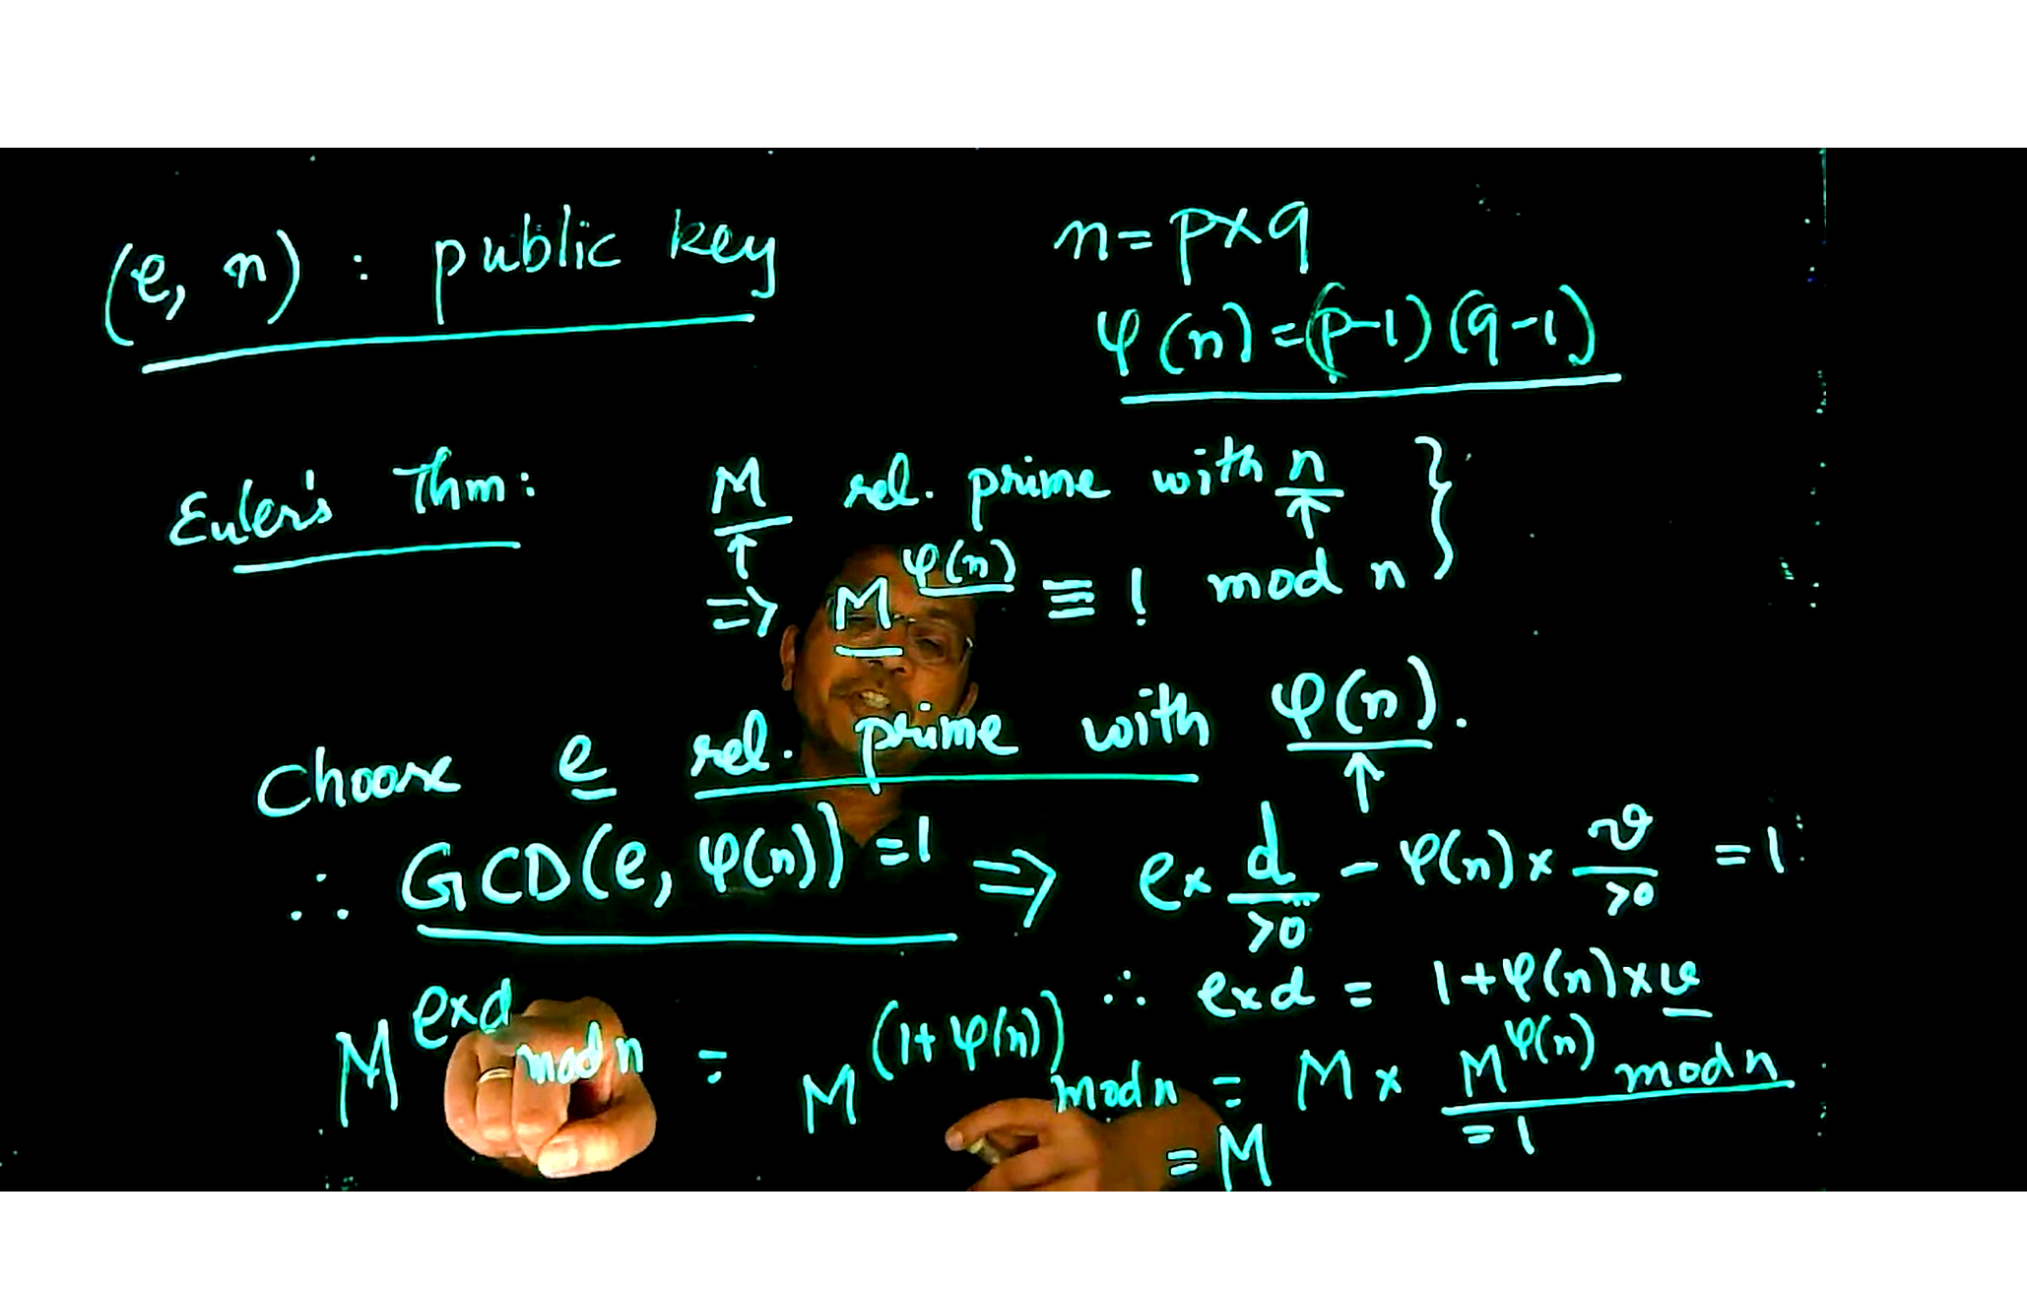

Below again using the using the encrypting and decrypting keys we can get back the original data

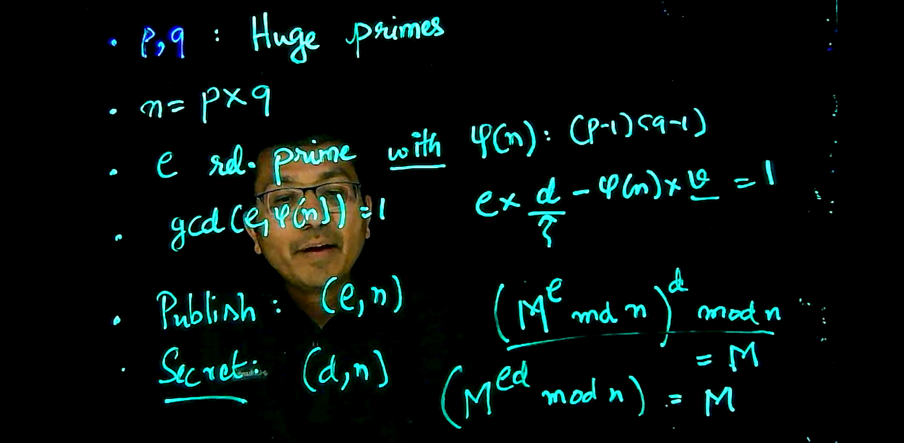

Now we use the real life case using this   


Can we find a way to reverse engineer the process and find the value d, can attackers do that?  
  
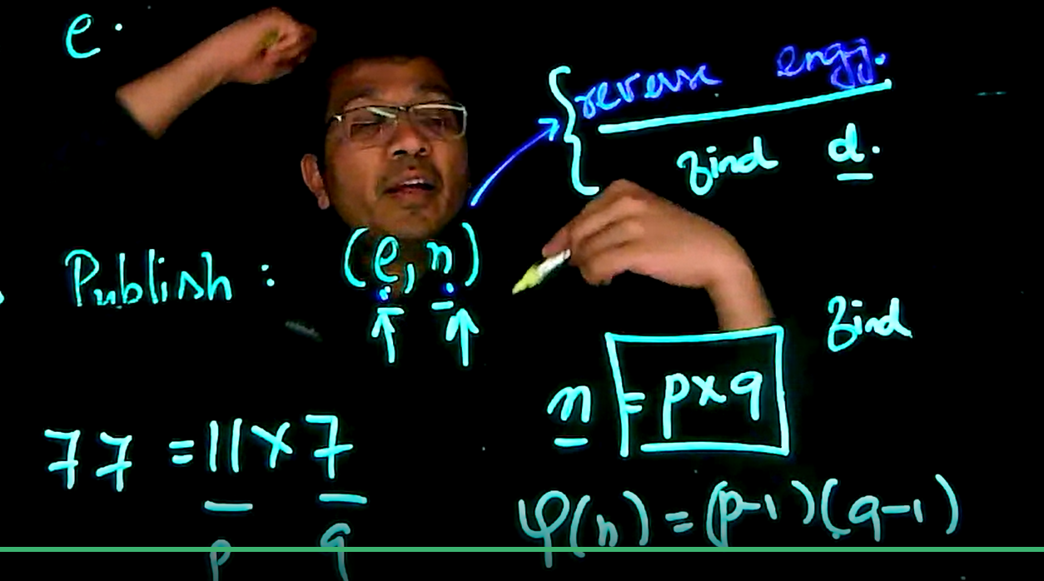

But its hard to find n, even with a for loop like this it wont work  
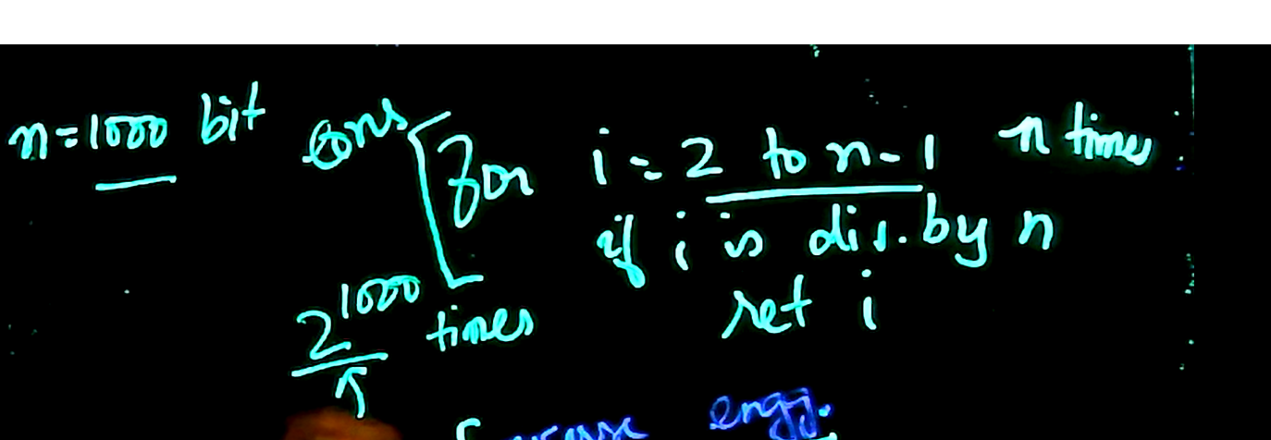  
As the loop has to run 2 raise to power 1000, which is very extensive

Check how to break the RSA Algo, by factoring and finding d which means q at the end, indicated below  
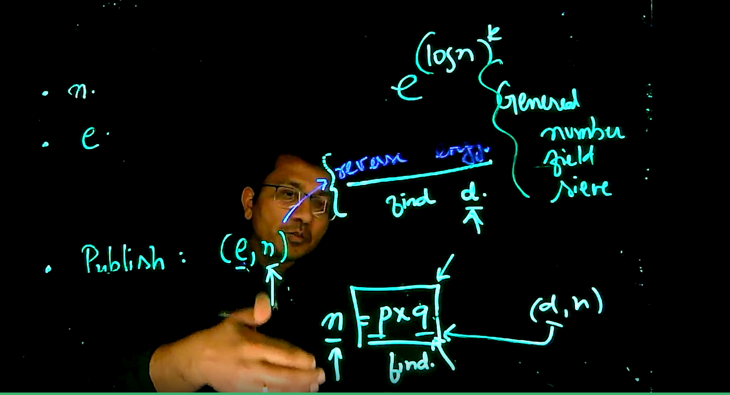  
  
  
**Breaking the RSA Algorithm**  
So if we can factor two numbers, right now we don’t have a efficient way but using Quantum Computing and a large enough computer can factor two numbers and that we can find p and q, classic computers cannot do it even with the best algorithm. So with Quantum computing can break the RSA Algorithms